

FindBugs Eclipse Plugin
User Manual

Record of change
*A - Added M - Modified D - Deleted
Effective Date | Changed Items | A*  M, D | Change Description | New Version
14th-Apr-09 | Create |  |  | 1.0
SIGNATURE PAGE

ORIGINATOR: Chu Canh Chieu <Date> 14th-Apr-2009
G1-Project Manager

REVIEWERS: <Date>

APPROVAL: <Date>

TABLE OF CONTENTS
1. Introduction and overview 5
2. Installation guide 7
2.1. Requirements 7
2.2. Installation 7
3. Getting started 10
4. Case Study 12

Introduction and overview
FindBugs is an open source static analysis tool that analyzes Java classfiles looking for programming defects. The analysis engine reports nearly 300 different bug patterns. FindBugs has a plugin architecture, in which detectors can be defined, each of which may report several different bug patterns. Rather than use a pattern language for describing bugs, FindBugs detectors are simply written in Java, using a variety of techniques. Many simple detectors use a visitor pattern over the classfiles and/or the method bytecodes, often using a state machine and/or information about the types, constant values, and special flags (e.g., is this value the result of calling hashCode) about values stored on the stack or in local variables. But detectors can also traverse the control flow graph, using the results of data flow analysis such as type information, constant values and nullness. The data flow algorithms all generally use information from conditional tests, so that information from instanceof tests and null tests are incorporated into the analysis results. FindBugs does not perform interprocedural context sensitive analysis. However, many detectors make use of global information such as subtype relationships and which fields are accessed across the entire application. A few detectors use interprocedural summary information, such as which method parameters are always dereferenced. Each bug pattern is grouped into a category (e.g., correctness, bad practice, performance and internationalization), and each report of a bug pattern is assigned a priority, high, medium or low. The priorities are determined by heuristics unique to each detector/ pattern, and are not necessarily comparable across bug patterns. In normal operation, FindBugs does not report low priority warnings. During the first summer FindBugs was applied at Google, substantial effort was put into trying to ensure that issues reported as high or medium priority correctness issues were issues that had a low false positive rate, and that developers would be interested in examining all issues reported as high or medium priority correctness issues, even in large code bases. Perhaps the most important aspect of FindBugs is how new bug detectors are developed: by starting with real bugs, and developing the simplest possible technique that effectively finds those bugs. This approach often allows us to go from finding a particular instance of a bug to implementing a detector that can effectively find it in a matter of hours. Many bugs are really very simple; one of the bug patterns most recently added to FindBugs is to cast an integer value to a char and then check to see if the result is -1. This bug was inspired by a post on http://worsethanfailure.com/, and within less than an hour we had implemented a detector that found 11 such errors in Eclipse 3.3M6. FindBugs can be run from the command line, Ant or Maven, or
in a GUI, Eclipse or NetBeans. The analysis results can be saved in XML, which can then be further filtered, transformed, or imported into a database. FindBugs supports two different mechanisms for matching defect warnings from different analysis runs (trying to match up a defect warning in one analysis with the corresponding warning in another analysis, despite program changes that may have changed line numbers).

Installation guide

Requirements
To use FindBugs, you need a runtime environment compatible with Java 2 Standard Edition, version 1.5 or later. FindBugs is platform independent, and is known to run on GNU/Linux, Windows, and MacOS X platforms.
You should have at least 512 MB of memory to use FindBugs. To analyze very large projects, more memory may be needed.
To use the FindBugs Plugin for Eclipse, you need Eclipse 3.3 or later, and JRE/JDK 1.5 or later.

Installation
To install the FindBugs plugin:
1. Configure Network Connection
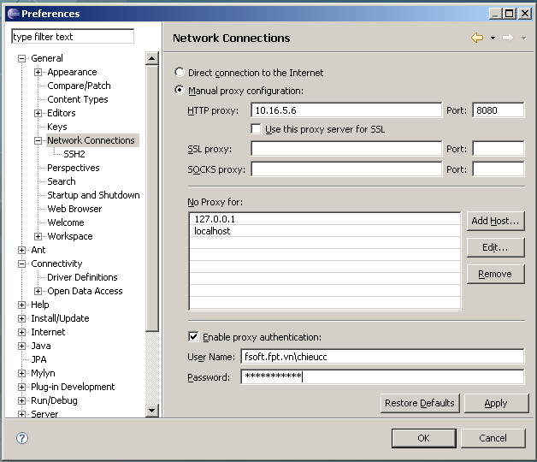
2. In Eclipse, click on Help -> Software Update -> Find and Install...
3. Choose the Search for new features to install option, and click Next.
4. Click New Remote Site.
5. Enter the following:
Name: FindBugs update site
URL: one of the following (note: no final slash on the url)
http://findbugs.cs.umd.edu/eclipse for official releases
http://findbugs.cs.umd.edu/eclipse-candidate for candidate releases and official releases
http://findbugs.cs.umd.edu/eclipse-daily for all releases, inculding developmental ones
and click OK.
6. "FindBugs update site" should appear under Sites to include in search.
Click the checkbox next to it to select it, and click Finish.
7. You should see FindBugs Feature under Select features to install.
(You may have to click on one or two triangles to make it visible in the tree.)
Select the checkbox next to it and click next.
8. Select the I accept option to accept the license and click Next.
9. Make sure the location is correct where you're installing it. The default (your workspace) should be fine. Click Finish.
10. The plugin is not digitally signed. Go ahead and install it anyway.
11. Click Yes to make Eclipse restart itself.
You can also manually download the plugin from the following link: http://prdownloads.sourceforge.net/findbugs/edu.umd.cs.findbugs.plugin.eclipse_1.3.8.20090315.zip?download. Extract it in Eclipse's "plugins" subdirectory. (So <eclipse_install_dir>/plugins/edu.umd.cs.findbugs.plugin.eclipse_1.3.8.20090315/findbugs.png should be the path to the FindBugs logo.)
Once the plugin is extracted, start Eclipse and choose Help → About Eclipse Platform → Plug-in Details. You should find a plugin called "FindBugs Plug-in" provided by "FindBugs Project".

Getting started
To get started, right click on a Java project, and select the option labeled "Find Bugs". FindBugs will run, and problem markers (displayed in source windows, and also in the Eclipse Problems view) will point to locations in your code which have been identified as potential instances of bug patterns.
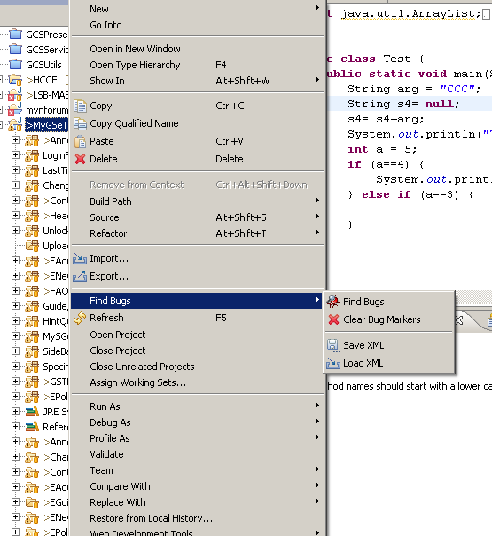
You may customize how FindBugs runs by opening the Properties dialog for a Java project, and choosing the "Findbugs" property page. Options you may choose include:
Enable or disable the "Run FindBugs Automatically" checkbox. When enabled, FindBugs will run every time you modify a Java class within the project.
Choose minimum warning priority and enabled bug categories. These options will choose which warnings are shown. For example, if you select the "Medium" warning priority, only Medium and High priority warnings will be shown. Similarly, if you uncheck the "Style" checkbox, no warnings in the Style category will be displayed.
Select detectors. The table allows you to select which detectors you want to enable for your project.
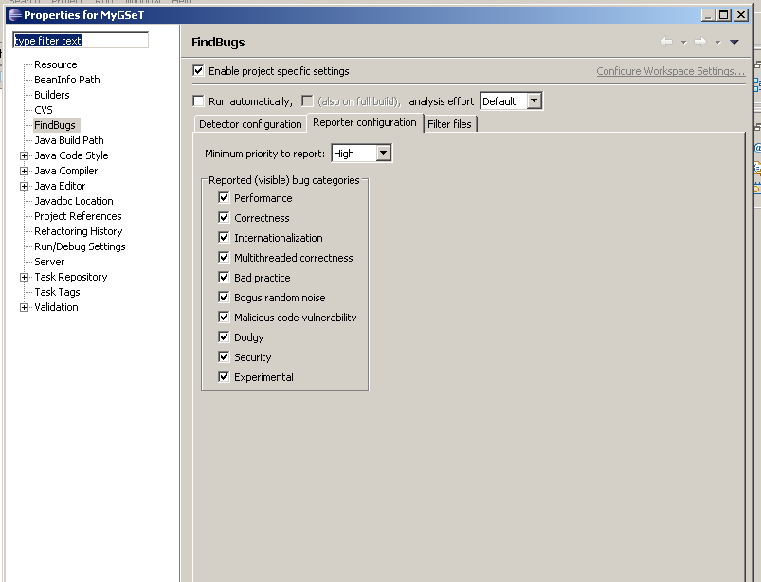

Case Study
Some potential errors (1815 in total) on LSB-MAS project were found by FindBugs.
